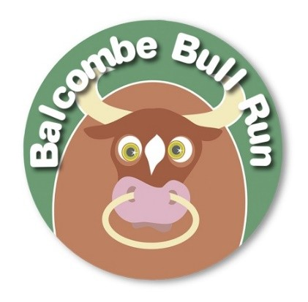
BALCOMBE BULL RUN 2020
Sunday 15th March

When: Sunday 15th March, 2020. Race starts at 10.30am
Where: Balcombe Primary School, Balcombe, West Sussex RH17 6HS – see map below
Distance: 7.1km on footpaths, fields, lanes and tracks……hilly course and it could be muddy and wet
Who for: All runners must be age 12 or over on 31/8/20 (under 16’s with signed consent)
How much: £12 for adults, £5 under 18s.

Course Route
http://www.gmap-pedometer.com/?r=6141126
PARKING
Parking
START / FINISH
There is extensive parking in the layby off the B2036 beside St Marys Church (150m from Registration). If you park in the village centre, please be mindful of local residents.
“Postman’s” walk
Steep hill
Registration
This is in the main hall of Balcombe School (see below) and is where you will collect your race number. Registration closes at 10.15am
START / FINISH
REGISTRATION

Refreshments
These will be available from 9.30am – tea, coffee, cake, bacon sandwiches, etc – and after the race until 12.15pm. Supporters are welcome in the school hall.

Application Form (one per runner…..PLEASE WRITE LEGIBLY)
Runner Name: ………………………………………………………… Runner’s Address:…………………….………………………………....
Adult □ £12 Under 18 □ £5 ………………………………………………………………………………………
Male □ Female □ Postcode:………………………………………………………………………
Emergency Telephone:…………..…………….…………………. Email:……………………………………………………………………………..
ONLINE ENTRY & PAYMENT IS AVAILABLE AT www.balcombeschool.co.uk
You can also TRANSFER the entry fee directly to Balcombe School PTA’s bank account
CAF Bank Ltd, Sort 40 52 40, account 00060230, Balcombe School PTA
Cheques payable to Balcombe School PTA

Entry fees paid? PayPal (through website) ⃝ Direct bank transfer ⃝ Cheque (enclosed) ⃝

Declaration
I declare that I am medically fit and capable of completely the event safely. I enter the race at my own risk. I will not hold the event organisers or any officials responsible for any accident, injury, loss or damage resulting from my participation in the race.
Signed:…………………………………………………………………………………………………………………………Date:…………………………………

Consent for under 16 year olds
I consent that the above named person is aged 12 or over of 31/8/20 and is medically fit and capable of completely the event safely. I confirm that they enter the race at their own risk and will not hold the event organisers or any officials responsible for any accident, injury, loss or damage resulting from their participation in the race.
Signed:…………………………………………………………………………………………………………………………Date:…………………………………
Name:…………………………………………………………………………Parent / Guardian
Race numbers will be given out on the day. Please register before 10.15am
SEND COMPLETED APPLICATION FORMS & ENTRY FEES TO:
Mat Record,
Afton House, Deanland Rd,
Balcombe, West Sussex RH17 6LX
More information available at www.facebook.com/BalcombeBullRun or phone 07795 451 156

