Balcombe C E (C) School
London Road, Balcombe, West Sussex, RH17 6HS
Headteacher: Wendy Millbanks
Telephone: (01444) 811403
Email: office@balcombeschool.co.uk
www.balcombeschool.co.uk

- General Details

Title of Post: Breakfast Club Manager
Hours: Monday to Friday 7.15 am to 9 p.m term time only
Start September 2019
Salary Grade: 4 (£18,795 to £19171 pro rata)

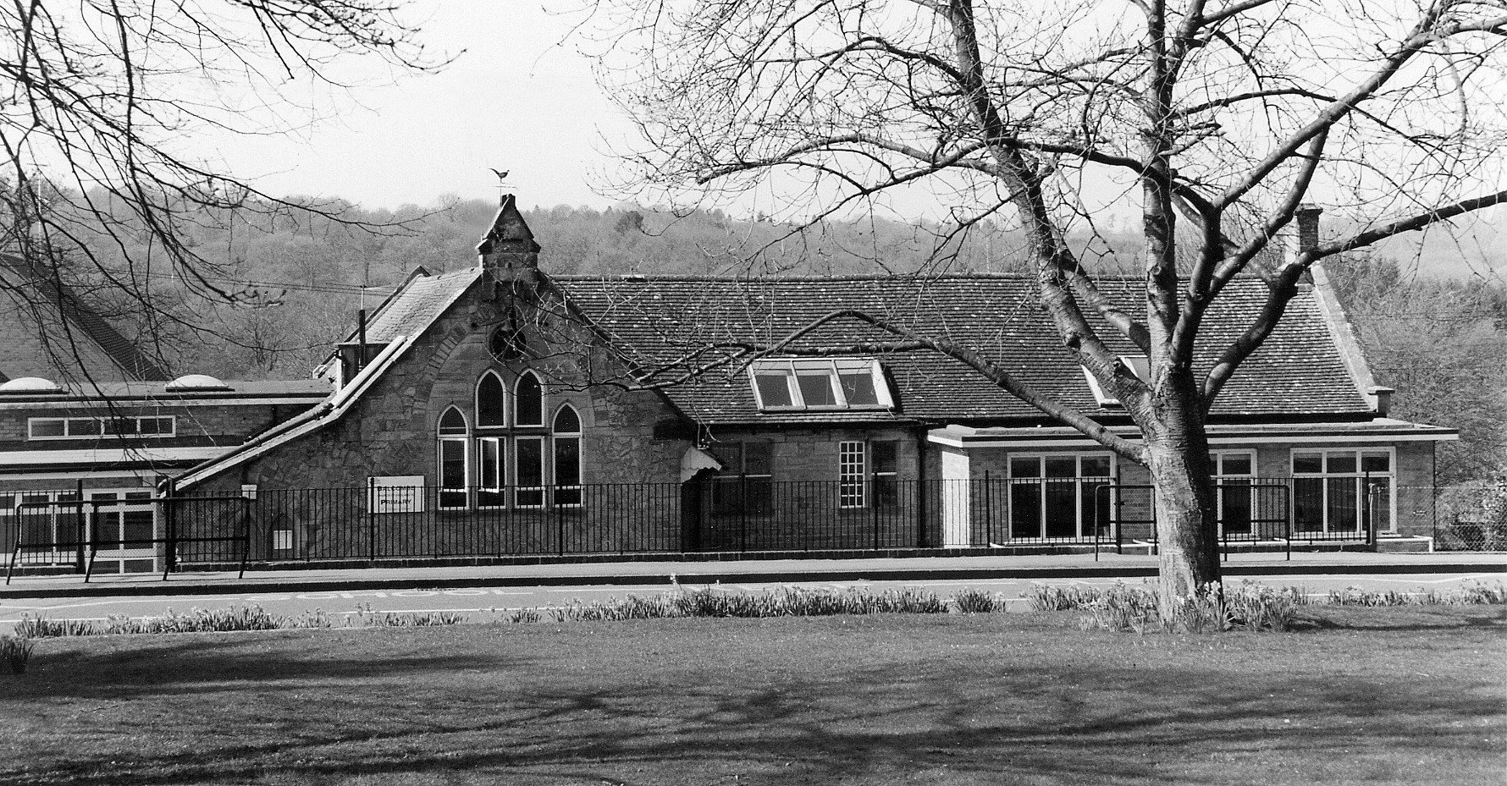

Balcombe is a friendly village community situated midway between Crawley and Haywards Heath in a designated area of outstanding natural beauty. The school plays an active part in community life.

Balcombe Primary School is a five class school, currently providing an excellent education for 130 pupils. The building is old, but well cared for and provides for a bright and cheerful environment. The grounds encorporate a ball court, stage, pond and wild area, which is also used to enhance learning. Our pupils are highly motivated and love coming into school.

- Purpose of the Role

- To lead a small team of colleagues in the management and day to day operation and organisation of The Breakfast Club.

- To ensure all children attending the breakfast club (including those who have individual needs or are vulnerable) start their day at Balcombe in a calm and positive manner.

- To develop a partnership with parents and establish a welcoming environment.

- General Duties

- To provide a secure, safe and stimulating environment for the children.

- To ensure the breakfast club area is appropriately resourced and maintained to a high standard.

- To plan menus, order and purchase provisions within the allocated budget.

- To prepare the children’s breakfast and clear away afterwards, encouraging the full involvement of pupils, as appropriate.

- To liaise with parents ensuring that they are kept fully informed about their child’s start and subsequent progress whilst they attend the breakfast club.

- To be well aware of the children’s personal, social and emotional needs and to respond to these appropriately, encouraging independence.

- To discuss individual children’s issues and development with the Headteacher and other members of staff as appropriate and to take any necessary action.

- To attend courses to ensure continuing professional development and to keep abreast of key developments that affects the breakfast club.

- Any other duties as may be reasonably required to reflect changing needs and circumstances within the breakfast club.

- Responsible to :

- Headteacher

Balcombe CE Primary School considers safeguarding to be of paramount importance.

The School is committed to safeguarding and promoting the health, safety and welfare of all children, young people, their families and staff. This means that everything we do is designed to promote the safety and well-being of the children we work with, as well as that of children and young people in general.

Closing date for applications – Wednesday 10th July at 12
Interviews – W/C 15th July
Vacancy description correct at the time of advertising positions

Essential | Desirable
- Available to work every day.  - Able to mulit-task and show flexibility.  - Genuine passion for working with children.  - Positive approach to problem solving. | - Previous experience working with infants.  - Creative and sporty.  - Maths, English GCSE or equivalent.
Person Specification

