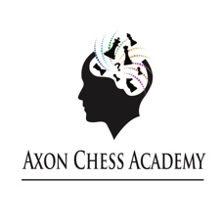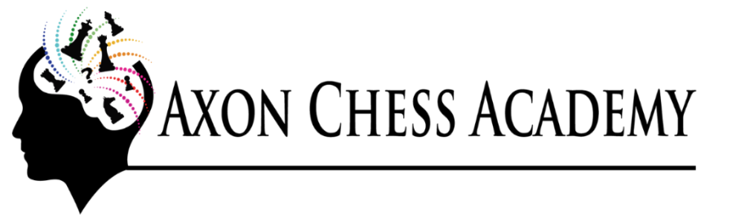
During the Autumn term from 18th September, we will be continuing the
BALCOMBE C OF E PRIMARY CHESS ACADEMY
The Academy is open to children, whether established player or complete beginner.
The coaching sessions are held on Wednesdays from 3.20pm until 4.20pm
Chess is fantastic to develop different mental skills including reasoning, logic, forward planning, and overlaps into other subject areas especially maths.
Throughout the year there will be a mix of coaching and playing sessions, with the aim of entering a
Balcombe C of E Primary School Chess Academy team in the
Delancey UK National Schools Chess Challenge
Our coaching is run along British Chess Institute coaching guidelines. During the term, we work towards achieving the Certificates of Chess Excellence. The certificate & assessment cost is included in the term fee.
The cost is £60 for the 12 chess sessions in the Autumn term, commencing on the 18th Sept 2019
(Full dates are 18/09, 25/09, 02/10, 09/10, 16/10, 23/10,
06/11, 13/11, 20/11, 27/11, 04/12, 11/12)
Places are limited so please book as soon as possible
Booking is by online payment to
Axon Chess Academy / Account Santander 27378599 / Sort code 09 01 29
Once you’ve made a payment, please email us. We will reply confirming the place.
www.axonchessacademy.com axonchessacademy@gmail.com
